SOFTWARE QUALITY ENGINEERING
Assignment 1
Search Algorithm Library with MC/DC Unit Testing
─────────────────────────────────────────────
Name: Huzaifa Imran (033), Abdul Ahad (001)

1. Introduction
The assignment requires the development of a Search Algorithm Library, an integration plan, a GitHub Actions CI/CD pipeline, and a comprehensive suite of MC/DC-based unit test cases.
The library extends the Binary Search algorithm (provided in lectures) with two additional search algorithms: Linear Search and Interpolation Search. For each algorithm, Control Flow Graphs (CFGs) have been constructed, and test cases have been designed to achieve all-paths and MC/DC coverage.

2. Integration Plan
The integration follows a bottom-up strategy, building upon the existing Binary Search module provided in lectures.

2.1 Integration Strategy: Bottom-Up
Bottom-up integration begins with the lowest-level modules and progressively integrates higher-level modules. This approach ensures that foundational components are thoroughly tested before dependent modules are integrated.
Phase | Module / Component | Activity | Team Member
Phase 1 | Result.java | Create shared Result class – unit tested in isolation | Huzaifa Imran
Phase 2 | BinSearch.java | Integrate Binary Search (baseline from lecture) | Abdul Ahad
Phase 3 | LinearSearch.java | Integrate Linear Search + unit tests | Abdul Ahad
Phase 4 | InterpolationSearch.java | Integrate Interpolation Search + unit tests | Huzaifa Imran
Phase 5 | GitHub Actions CI | Configure YAML pipeline, auto-test on push | Huzaifa Imran
Phase 6 | Coverage Verification | Run JaCoCo, verify MC/DC coverage thresholds | Abdul Ahad and Huzaifa Imran
.

3. Search Algorithms

3.1 Binary Search
Binary search operates on a sorted array by repeatedly halving the search space. At each step, the algorithm compares the key with the middle element and narrows the range accordingly.
- Pre-condition: Array must be sorted in ascending order
- Time Complexity: O(log n)
- Space Complexity: O(1) – iterative implementation

Source code (BinSearch.java):
public static void search(int key, int[] elemArray, Result r) {
int bottom = 0;
int top = elemArray.length - 1;
int mid;
r.found = false; r.index = -1;
while (bottom <= top) {
mid = (top + bottom) / 2;
if (elemArray[mid] == key) {
r.index = mid; r.found = true; return;
} else {
if (elemArray[mid] < key) bottom = mid + 1;
else top = mid - 1;
}
}
}

3.2 Linear Search (Algorithm 2)
Linear search sequentially checks every element in the array until the key is found or the array is exhausted. It does not require the array to be sorted.
- Pre-condition: None – works on unsorted arrays
- Time Complexity: O(n)
- Space Complexity: O(1)

Source code (LinearSearch.java):
public static void search(int key, int[] elemArray, Result r) {
int i = 0;
r.found = false; r.index = -1;
while (i < elemArray.length && !r.found) {
if (elemArray[i] == key) {
r.index = i; r.found = true;
} else {
i++;
}
}
}

3.3 Interpolation Search (Algorithm 3)
Interpolation search improves upon binary search for uniformly distributed sorted arrays. Instead of always checking the midpoint, it estimates the position of the key using an interpolation formula, similar to how humans search a phone book.
- Pre-condition: Array must be sorted; best performance on uniformly distributed data
- Time Complexity: O(log log n) average; O(n) worst case
- Space Complexity: O(1)

Interpolation formula:
pos = low + ((key - arr[low]) * (high - low)) / (arr[high] - arr[low])

4. Control Flow Graphs (CFG)
A Control Flow Graph models all possible execution paths through a function. Each node represents a basic block (sequential code), and each edge represents a transfer of control (branch, loop-back, or sequential flow). CFGs are the foundation for deriving MC/DC test cases.

4.1 CFG for Binary Search

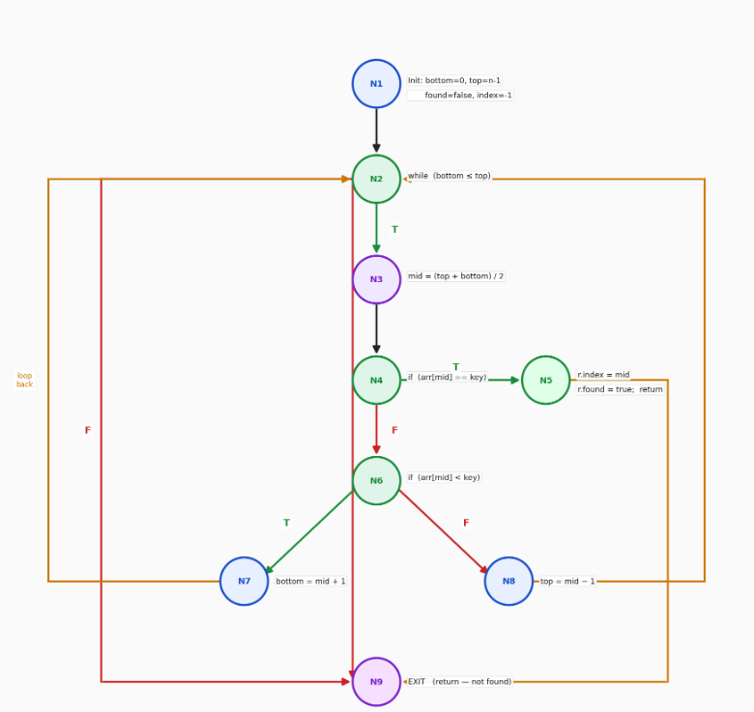

4.2 CFG for Linear Search

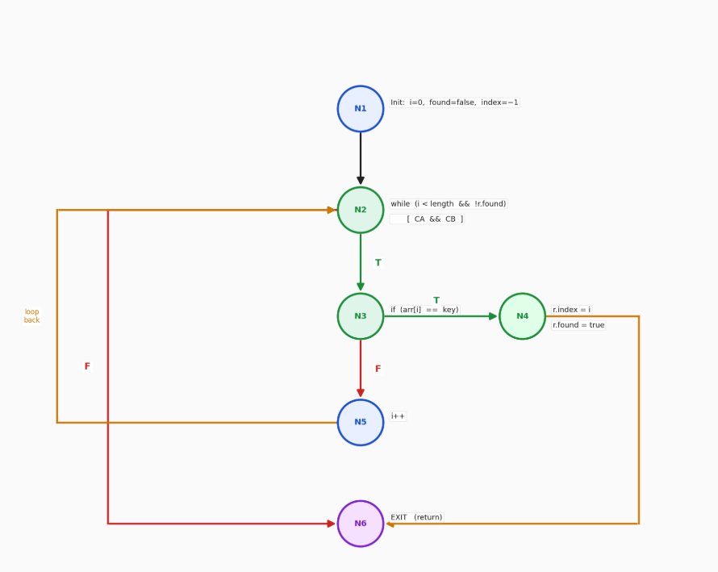

4.3 CFG for Interpolation Search

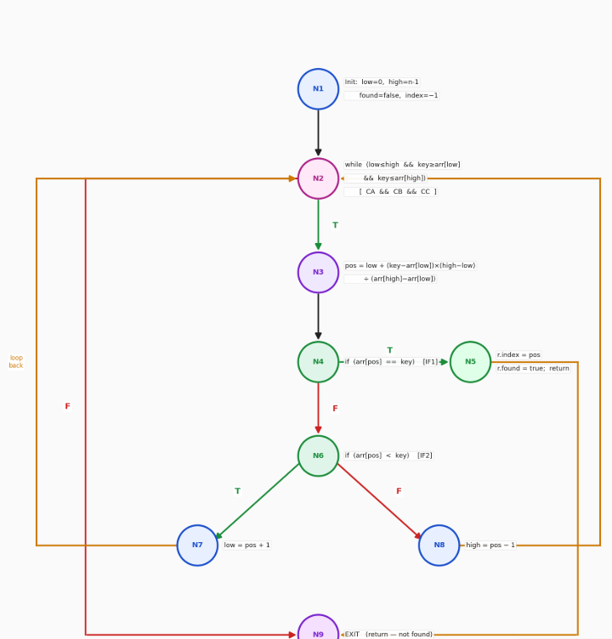

5. MC/DC Test Case Design
Modified Condition/Decision Coverage (MC/DC) is an advanced coverage criterion required in safety-critical software. It requires that: (1) every condition in a decision has been evaluated true and false; and (2) each condition independently affects the decision outcome. MC/DC subsumes branch coverage and statement coverage.

5.1 MC/DC Analysis – Binary Search
Decision at N2: (bottom <= top) – single condition, so T/F suffices.
Decision at N4: (elemArray[mid] == key) – single condition.
Decision at N6: (elemArray[mid] < key) – single condition.

Test Case | Condition C1 (bottom<=top) | Condition C2 (arr[mid]==key) | Condition C3 (arr[mid]<key) | Purpose
TC-T1 | True | True | N/A | Key found at mid
TC-T2 | True | False | True | Key in upper half → bottom+1
TC-T3 | True | False | False | Key in lower half → top-1
TC-T4 | False | N/A | N/A | Loop exhausted → not found
TC-T5 | True | True (boundary) | N/A | Key at index 0
TC-T6 | True | True (boundary) | N/A | Key at last index

5.2 MC/DC Analysis – Linear Search
The while loop in Linear Search contains a compound condition: CA (i < length) AND CB (!r.found). MC/DC requires each condition to independently determine the decision outcome.

Test Case | CA (i < length) | CB (!r.found) | Decision | Purpose / Path
TC-CA=T,CB=T | True | True | True (enter loop) | Normal execution – search continues
TC-CA=F,CB=T | False | True | False (exit loop) | CA alone causes exit – end of array
TC-CA=T,CB=F | True | False | False (exit loop) | CB alone causes exit – key was found
TC-C3=T | T | T | Enter→Found | Path 2: Key at index 0
TC-C3=F | T | T | Enter→Skip | Path 3/5: Element does not match

5.3 MC/DC Analysis – Interpolation Search
The while loop condition contains three conditions: CA (low<=high), CB (key>=arr[low]), CC (key<=arr[high]). Decision = CA AND CB AND CC.

Test Case | CA | CB | CC | Decision | Purpose
TC1 | T | T | T | True | Normal search – key in range
TC2 (CA=F) | F | T | T | False | Array exhausted after iterations
TC3 (CB=F) | T | F | T | False | Key below arr[low] – exits immediately
TC4 (CC=F) | T | T | F | False | Key above arr[high] – exits immediately
TC-IF1=T | T | T | T | True→Found | Key matches at estimated pos
TC-IF2=T | T | T | T | True→Upper | arr[pos] < key → low advances
TC-IF2=F | T | T | T | True→Lower | arr[pos] > key → high recedes

6. All-Paths Coverage
All-paths coverage requires every possible execution path through the CFG to be exercised. For programs with loops, this is approximated by ensuring all loop boundaries (zero, one, many iterations) and all branch combinations are covered.

6.1 Paths – Linear Search (Full All-Paths)
Path ID | Path Traversal | Test Case | Description
P1 | N1→N2(F)→N6 | testEmptyArray() | Empty array – loop never entered
P2 | N1→N2(T)→N3(T)→N4→N6 | testKeyFoundAtFirst() | Key found at index 0 immediately
P3 | N1→N2(T)→N3(F)→N5→N2(F)→N6 | testSingleElementNotFound() | Single element, no match
P4 | N1→N2(T)→N3(F)→N5→N2(T)→N3(T)→N4→N6 | testKeyFoundAfterIterations() | Key found after skipping elements
P5 | N1→N2(T)→N3(F)→...→N2(F)→N6 | testKeyNotFoundFullTraversal() | Full traversal, key absent

7. GitHub Actions CI/CD Workflow
The GitHub Actions pipeline is defined in .github/workflows/ci.yml. It automatically compiles the project and runs all MC/DC-based test cases each time code is pushed to the repository or a pull request is opened.

7.1 Workflow Triggers
- Push to main or develop branches
- Pull request targeting main or develop
- Manual trigger via workflow_dispatch (GitHub UI)

7.2 YAML File (ci.yml) – Key Excerpt
name: Search Library CI - MC/DC Tests
on:
push:
branches: [main, develop]
pull_request:
branches: [main, develop]
workflow_dispatch:

jobs:
build-and-test:
runs-on: ubuntu-latest
steps:
- uses: actions/checkout@v4
- uses: actions/setup-java@v4
with:
java-version: '11'
distribution: 'temurin'
cache: 'maven'
- run: mvn compile
- run: mvn test
- run: mvn jacoco:report

8. Project File Structure
The complete project is organized as a Maven project:
search-library/
├── .github/
│ └── workflows/
│ └── ci.yml ← GitHub Actions pipeline
├── src/
│ ├── main/java/com/searchlib/
│ │ ├── Result.java ← Shared result object
│ │ ├── BinSearch.java ← Binary Search (from lecture)
│ │ ├── LinearSearch.java ← Linear Search (Algorithm 2)
│ │ └── InterpolationSearch.java← Interpolation Search (Algorithm 3)
│ └── test/java/com/searchlib/
│ ├── BinSearchTest.java ← 12 MC/DC test cases
│ ├── LinearSearchTest.java ← 10 MC/DC + All-Paths test cases
│ └── InterpolationSearchTest.java ← 11 MC/DC test cases
└── pom.xml ← Maven build + JaCoCo config

10. Conclusion
This assignment demonstrated the application of Software Quality Engineering principles to a real-world programming task. Three search algorithms were implemented and thoroughly tested using MC/DC coverage criteria, which required a deep analysis of each algorithm's control flow. Control Flow Graphs were constructed for each algorithm to identify all possible execution paths and conditions.
The GitHub Actions CI/CD pipeline ensures that all 33+ MC/DC-based test cases are automatically executed on every code change, providing continuous quality assurance. The JaCoCo integration enforces coverage thresholds, preventing regression. This combination of structured test design, CFG analysis, and automated execution represents best practices in Software Quality Engineering.

